Drash on Shemot (Exodus 1:1-6:1)
Ahavat Yeshua DC Service
January 10, 2026
David L. Craig
Parashat Shemot (שְׁמוֹת) is the first parashat of the second book of the Torah which shares its Hebrew name. The English title of the book, Exodus, is taken directly from the Septuagint’s Greek title literally meaning Way Out. The Hebrew name arose from the second word which in English means names, referring to the immediately following list of the sons of Jacob. The book chronicles the history of the Jewish people from the waning of Joseph’s influence in Egypt through God’s arrival in the newly completed Wilderness Tabernacle.
The parashat can be summarized thusly:
After God’s people had settled in Egypt, they lost their favored status while they multiplied greatly, until new leadership decided to enslave them and later forced grievous population controls upon them. Into this reality Moses was born and unexpectedly adopted by Pharaoh's daughter to be raised in her father’s court. As an adult, Moses killed an Egyptian taskmaster and fled for his life to Midian where he became a shepherd for forty years. Then God appeared to him and called him to return to Egypt to lead the Jewish people out of Egypt and into a land of their own. His first meeting with Pharaoh resulted in worse conditions for the slaves, leading Moses to lament the situation to God Who repeated He will compel Pharaoh to change his mind after tremendous tsuris has been experienced by Egypt.
Yah-a-mod, Elaine bat Benyamin Moshe. Elaine will read for us, from the Biblehub.com interlinear Bible, Exodus chapter 4, verses 24 through 26, alternating between each Hebrew word and its English translation:
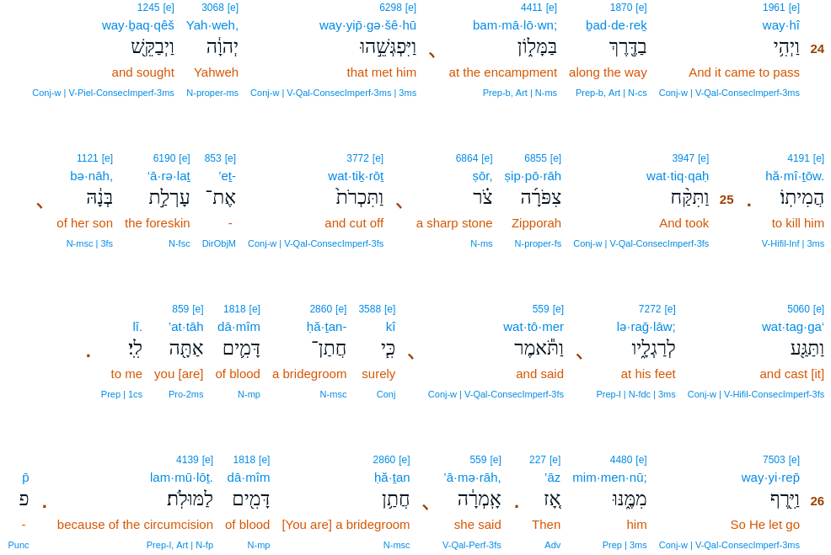
Thank you, my bride.
Was that too hard to follow? Okay, here’s the straight Amplified Bible translation (which adds explanations the authors believed are needed and are supported by the rest of Scripture):
24 Now it happened at the lodging place, that the Lord met Moses and sought to kill him [making him deathly ill because he had not circumcised one of his sons]. 25 [y]Then Ziporrah took a flint knife and cut off the foreskin of her son and threw it at Moses’ feet, and said, “Indeed you are a husband of blood to me!” 26 So He let Moses alone [to recover]. At that time Zipporah said, “You are a husband of blood”—because of the circumcision.
Two years ago, my drash on this parashat focused on Moses’ humility. I briefly commented therein on my view of these verses. I intend to provide greater clarity within this drash regarding that point of view as well as others.
Most translations indicate Ziporrah actually said that last Hebrew word, “because of the circumcision”. The Torah does not have quotation marks, however, so there is room for translators to ascribe that last word to the narrator as is the case in the Amplified Bible. In other words, their interpretation is the entire last sentence is voiced by the narrator who partially quotes what Ziporrah said earlier, thus indicating Zipporah said only one sentence in these verses and never mentioned circumcision.
I point this out to put forward for your consideration that translations can be very tricky. As to which translation of that last verse is correct, I leave that determination to you as an exercise.
Much of Scripture is puzzling on the surface. However, this wife of Moses remains enigmatic as you dig down into her life. So much about Moses’ entire family is not mentioned. When was Ziporrah born relative to Moses’ birth? We do not know. We also do not know when she died. How long had they been married when this circumcision occurred? How old was this son who needed to be circumcised? What was his name? None of these questions are definitively answered in The Scriptures. Here is what we know:
Immediately after Ziporrah’s father told his daughters to bring the man who had aided them home, it is written:
21 Moses was willing to remain with the man, and he gave Moses his daughter Zipporah [to be his wife]. 22 She gave birth to a son, and he named him Gershom (stranger); for he said, “I have been a stranger in a foreign land.”
Then in chapter 4 verse 20 we read:
So Moses took his wife [Zipporah] and his sons [Gershom and Eliezer] and seated them on donkeys, and returned to the land of Egypt.
The Hebrew clearly reads sons plural without any names, but both Exodus chapter 18 verses 2 through 4 and I Chronicles chapter 23 verse 15 identify these two sons of Moses. The Scriptures do not conclusively state Moses had only two sons, but there is no mention of any other children, male or female. While Scripture does not explicitly state Gershom was firstborn, verse 22 strongly suggests this. The Scriptures say nothing about them being twins or not, but nothing suggests that was likely.
After this story of the circumcision, we have to read way ahead to Exodus chapter 18 in Parashat Yetro to encounter the next Scripture touching on Moses’ family. Depending upon how the reader interprets the Hebrew, it merely mentions that Moses had either (1) sent his family away and they returned to him along with his father-in-law at Mount Sinai, or (2) that he had divorced Zipporah, sent his family away, they went back to her father who took them in, and they did not return to Moses when her father went to Mt. Sinai. You should know many prominent rabbis including Rashi have subscribed to the divorce reading. There other variants of this basic difference as well.
However, this family history is only mentioned in passing, as the focus is upon Moses’ father-in-law, who accepts Moses’ God as The Almighty, then advises Moses to share his judicial load. It becomes clear the Torah discusses Jethro far more than Ziporrah, Gershom, and Eliezer put together.
There are more unaddressed questions about Moses’ family. Was the son circumcised in this passage the older of the two? We have to reason that answer out, and it seems probable he was the younger and that his older brother was already circumcised at this time. If neither son was circumcised, we have to develop a plausible explanation for why the other brother’s state of uncircumcision was not also problematic for The Lord. Or was an unmentioned second circumcision also performed at this time? If one was already circumcised, why was other uncircumcised at this time? Was there disunity between Moses and Ziporrah about circumcision? That seems likely, but the Scriptures do not make it plain. Did Moses and his assailant say not a word in this anecdote or were their words simply not recorded? We have to imagine all inflection and body language, although conjoining Ziporrah’s words with the action of throwing the foreskin at someone’s feet under such circumstances merely suggests there was some degree of animosity afoot. Not everyone reads it that way, though. More than one commentator has gushed about how heroic and quick-thinking Ziporrah was to act so purposefully to save her husband’s life who was defying The Lord about the covenant of circumcision, much like Abigail protecting her community from the folly of her husband Nabal. The Scripture’s terseness opens the door to such exegesis.
We have to guess that, at the time Ziporrah met Moses, she subscribed to the religion of her father who was the spiritual and likely governmental leader of at least a tribe of people. Did Ziporrah ever embrace Moses’ god as her father did? If so, when? The Scripture also is silent about how Moses and Ziporrah felt about each other. It does not say he delighted in her, nor that he was emotionally distant from her, nor that he was indifferent to her, and vise-versa.
It is healthy curiosity to wonder why The Scriptures tell us so little about Moses’ family and to puzzle out possible answers. However, it may be unreasonable to expect to learn the truth as it is probably unnecessary for us to know more. Indeed, it may be necessary for us not to know more. To conjecture about Biblical unknowns may not be harmful, but, short of a word of knowledge clearly labeled as such, to present such musings as factual is likely mishandling Scripture and may cause others to stumble. If my drash on Moses’ humility caused you to think my opinion of why The Lord sought to kill Moses was definitive, I repent of misleading you and beg your forgiveness. The only truth is we don’t know why this happened. We can only guess, apparently as God intended.
While it would be very helpful to know Yeshua’s opinion of everything thus far recorded in the sea of the Talmud, The Scriptures only directly reveal a few things He affirmed and a few things He did not affirm. Consequently we must be very slow to ascribe authority to any writings that are not canonical Scripture. As good Bereans, be very careful to not jump to any conclusions as you puzzle out Biblical ambiguities, nor to take as Gospel anyone’s opinion on such matters without undertaking rigorous examination of such opinions. Remember your scholarship will be graded by The Lord.
The next parashat is Va'era and spans Exodus chapter 6 verse 2 through chapter 9 verse 35.

